📘 Chapter 10 – CSS Gradients: Rangon Ka Fusion 💥

🎯 What is a Gradient?
Gradient = Do ya zyada colors ka smooth mix
Jahan ek color se doosra slowly blend hota hai.
Jaise sunset sky mein orange → pink → purple 😍
CSS me 2 type ke gradients hote hain:
- Linear Gradient (Sidha line mein)
- Radial Gradient (Gol gol center se)

🔶 1. Linear Gradient
Color change hota hai straight line mein (top → bottom, left → right, etc.)

✅ Syntax:
background: linear-gradient(direction, color1, color2, ...);

🧪 Example 1: Top to Bottom
<div style="height: 150px; background: linear-gradient(to bottom, red, yellow);">
🔻 Top to Bottom Gradient
</div>
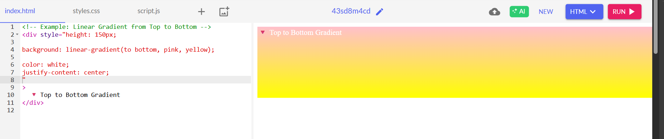

- 🧪 Example 2: Left to Right
<div style="height: 150px; background: linear-gradient(to right, #00f, #0ff);">
🔁 Left to Right Gradient
</div>
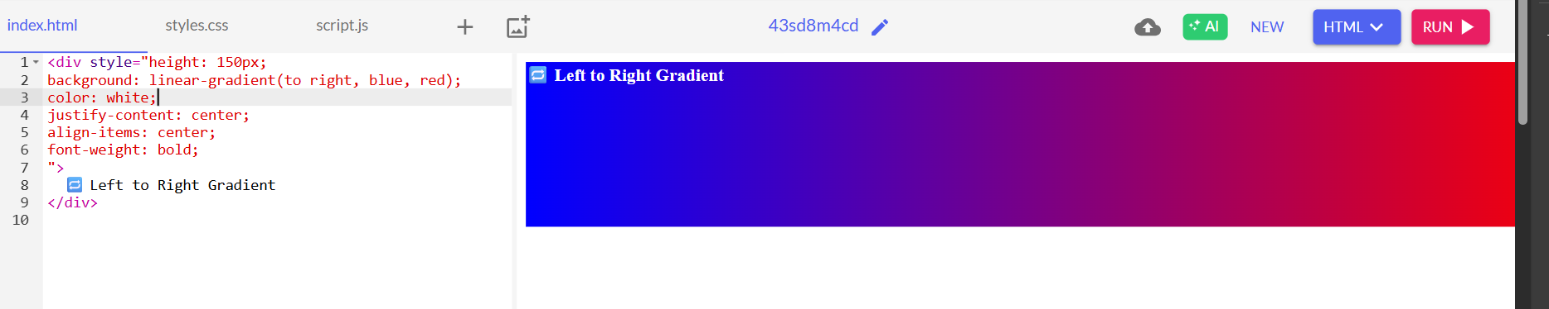

🧪 Example 3: Diagonal Gradient
<div style="height: 150px; background: linear-gradient(45deg, purple, pink);">
🔄 Diagonal 45 Degree Gradient
</div>

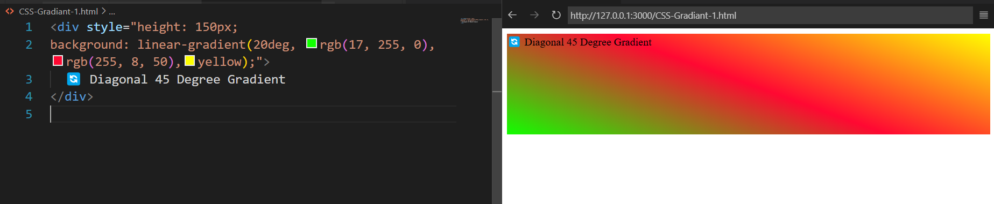

🎯 Color Stops – Gradient Me Rukawat Lagana
background: linear-gradient(to right, red 30%, yellow 70%);
🧠 Matlab:
- Red: 0% to 30%
- Yellow: 30% to 100%
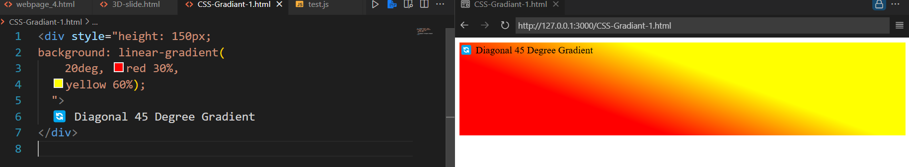

🟠 2. Radial Gradient
Color change hota hai center se gol gol shape mein

✅ Syntax:
background: radial-gradient(shape size at position, color1, color2);

🧪 Example: Center Se Outward
<div style="height: 150px; background: radial-gradient(circle, orange, black);">
🌕 Radial Gradient – Sun Type
</div>
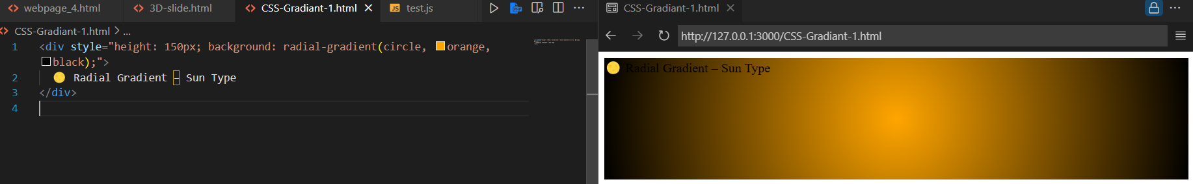

🧪 Elliptical Gradient:
<div style="height: 150px; background: radial-gradient(ellipse
,#f00, #fff);">
🥚 Egg Shape Gradient
</div>

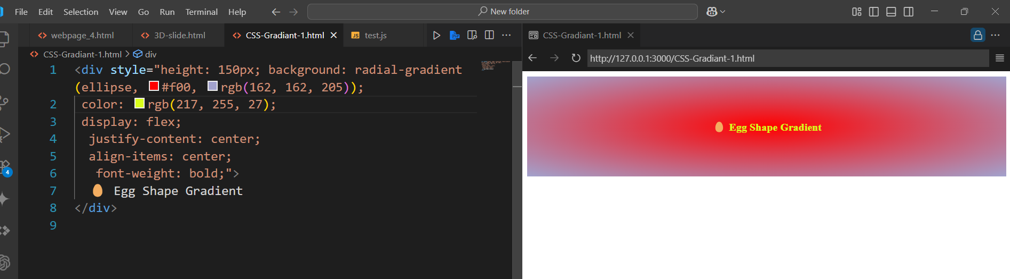

- Combine gradients with hover, text, or borders

🌟 Bonus: Gradient Button
<style>
.gradient-btn {
background: linear-gradient(to right, #ff416c, #ff4b2b);
padding: 10px 20px;
border: none;
border-radius: 30px;
color: white;
font-weight: bold;
transition: 0.4s;
}

.gradient-btn:hover {
background: linear-gradient(to right, #4facfe, #00f2fe);
}
</style>

<button class="gradient-btn">🔥 Gradient Button</button>

